Assignment 3: Hexapod
Goal is to model the embedded software of a hexapod robot.

A Hexapod robot is to mimic the form and behavior of 6-legged animals, such as e.g. crabs, beetles or cockroaches.

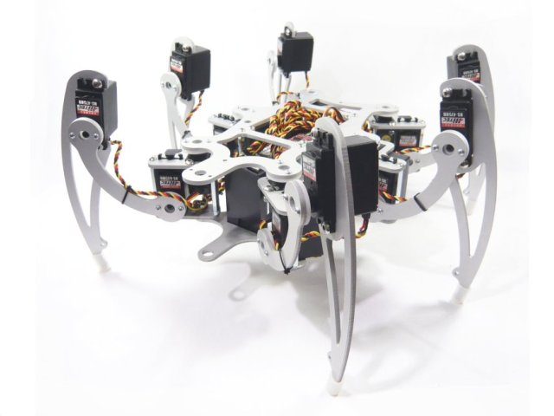

Preparations
A template project is available for your convenience. Download and unzip the file “MDD6_MDDHexapod.zip”.

Structure
The Hexapod has 6 legs to move and 1 sensor to warn for possibly dangerous situations or pray catch opportunities.

The “Leg” and “Sensor” blocks have already been provided and are ready for use as-is. They should NOT be modified! The rest of the model is up to you. You must draw at least a Block Definition Diagram with all blocks and interfaces (in the Design package) and an Internal Block Diagram (in the Test package).

Behavior
The behavior of the Hexapod that you have to model has to comply with the following requirements:
- The Hexapod’s basic behavior is: resting for 5 seconds, then moving for 20 seconds, then resting again, etc.
- When going to rest all the legs need to be relaxed (evRelax)
- Before the Hexapod can move all its legs need to be stiffened (evStiffen).
- While moving the Hexapod must use the so called “(alternating) tripod gait”. See below for more information. It is important that the Hexapod is always in a stable situation, i.e. in all circumstances it must have at least 3 legs (either legs 1,3,5 or legs 2,4,6) standing on the floor.
- When the Sensor signals an alarm (evAlarm) the Hexapod must freeze, i.e. it must stop moving immediately and freeze (evFreeze) all its legs. It must remember its current state to be able to continue later.
- When the Sensor signals the end of the alarm situation (evClear) then the Hexapod must unfreeze its legs (evContinue) and continue its movement. The movement must continue from the exact situation when it was frozen.
- When the Hexapod is resting, it must not react to Sensor input.

Note:
When we would write action code that would read the real sensor and would drive the real servo motors of the legs we could generate, compile and download the generated code into a real Hexapod and make it run. Instead in our model the legs and the sensor just print in the console what they are (supposed to be) doing.
Tripod gait
Spiders (and other insects) move their legs in a certain pattern such that they are always in a stable position. They always keep at least three legs standing on the floor. In fact there are several ways of stable walking. In our Hexapod robot model you must implement one specific way of walking, called “(alternating) tripod gait” where the Hexapod moves the tripod consisting of legs 1, 3, 5 followed by the tripod consisting of legs 2, 4, 6, followed by the first tripod again, etc.

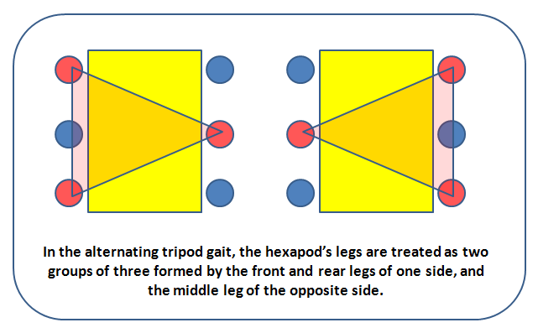
1
2
3
4
5
6
1
2
3
4
5
6
More information about tripod and other gaits:
- http://hexapodrobots.weebly.com/types-of-robot-gait.html
- http://www.youtube.com/watch?v=nRtJu4qrqn0

http://en.wikipedia.org/wiki/Hexapod_(robotics)

